VISITAR Platform

*Overview and Customer Setup Guide (Tech Pundits Internal Use Only)*

Purpose of This Guide  
This document provides a high-level overview of the VISITAR platform, guidance on onboarding new customers, setting up Entities and Sites, and managing ongoing customer configurations. It also includes internal instructions for applying custom portal color schemes for a new customer.

1. Platform Overview  
VISITAR is a role-based visitor management system designed to support secure and efficient visitor check-ins across multiple sites. The platform includes the following components:

|  |  |  |
| --- | --- | --- |
| **Component** | **Description** | **Access** |
| Admin Portal | Top-level admin portal used by Tech Pundits to create/manage customers | Tech Pundits |
| Customer Portal | Used by customer Entity Admins to upload logos, configure waiver policies, and connect Active Directory | Customers |
| Receptionist Portal | Used by receptionists to view/manage visitors across an Entity | Customers |
| Tablet App | Installed on-site & enables visitors to check in, take a photo & print badge | Visitors |

# 2. Roles & Access Control

|  |  |  |
| --- | --- | --- |
| **Role** | **Description** | **Access Scope** |
| Super Admin *(Tech Pundits)* | Full control of all customers, including Entities and Sites. | All Entities & Sites |
| Entity Admin *(Customer)* | Manages branding, waiver policy, AD integration. | All Sites in their Entity |
| Receptionist *(Customer)* | Manages visitor check-ins and badge printing. | Specific Site(s) |

3. Entity & Site Setup  
Tech Pundits is responsible for setting up each new customer in the Admin Portal.

**Steps:**

1. Log into the VISITAR Admin Portal.
2. Create a New Entity
   * Enter company name and contact info
3. Add Site(s) Under the Entity
   * Input site name and requested information
4. Generate Credentials for Entity Admin
   * Create user under the new Entity
   * Provide access details to the customer contact
5. Navigate to General Settings --> Site Settings
   * Add a valid email address for support requests in the Support Email field
6. Configure Equipment Package for each Site
   * Install VISITAR app on tablet
   * Set tablet configurations VISITAR App

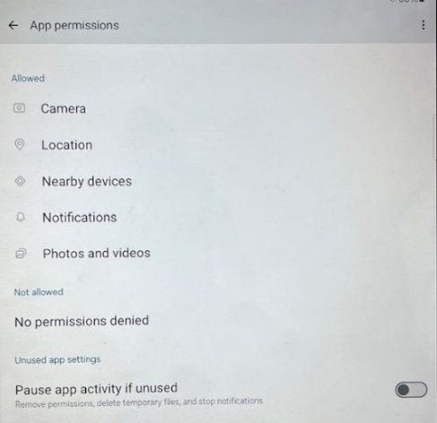

* + Disable auto-lock or extend screen timeout for kiosk mode if required
  + Connect printer to tablet
    1. <<<Confirm and add here>>
  + Configure internal printer settings
    1. <<<Confirm and add here>>>
  + Insert the DK-2205 label roll and feed it through the front slot
  + Print test badge
  + Discard additional label rolls supplied with the printer
  + If sending equipment for multiple sites clearly mark pre-configured tablets and printers
  + Print and include document with Customer Portal URL
  + Under Settings, configure the VISITAR Application language to Spanish if sending to Mexico

4. Subscription Management  
Each Entity is billed monthly based on the number of active Sites. The Admin Portal will be the source of truth for the number of active Sites, but pricing details are managed outside the portal. The pricing/billing should align with the Site count shown in the Admin Portal.

5. Configuring Customer Portal Color Scheme  
Each customer can have a custom base color applied to their Customer Portal and Receptionist Portal.

* The default color is red, but configurations can be made in the code to adapt to each customers brand if desired.
* Future customers may request a different base color (such as blue, green, or teal).

Note: The VISITAR Admin Portal will remain in grayscale. Color customization should only be applied to the customer facing portals (Customer and Receptionist), and not to the Admin Portal interface.

# 6. Internal Support & Escalation

| **Scenario** | **Escalate To** |
| --- | --- |
| AD/Teams integration failure | ????? |
| Tablet camera or printer issues | ????? |
| Waiver content not saving | ????? |
| Role assignment conflict | ????? |

Use Slack channel #visitar-support or open a ticket in Jira under project VISITAR-OPS.

7. Example Host Email

Once deployed at the customer site we will want to ensure the email formatting is correct and the buttons work with the system.